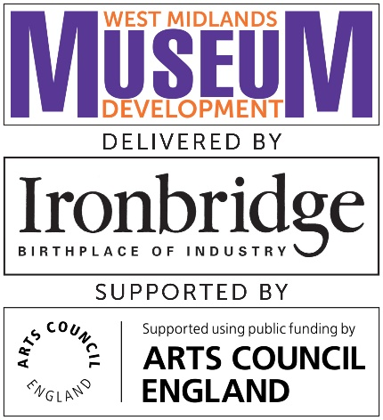

Bursary to attend Conference 2020
Thursday 19 March
9.15am – 6 pm, Ironbridge Gorge Museum Trust, Coalbrookdale TF8 7DQ

This bursary is offered to enable eligible delegates to attend the Ironbridge conference, part of Ironbridge Gorge Museum Trust’s National Portfolio Organisation and Museum Development programmes.

Eligibility:
- Open to volunteers, staff and trustees from Accredited Museums and those officially Working Towards Accreditation in the West Midlands region
- Up to £50 towards travel costs payable after the conference on production of receipts
- Complete, sign and return this form by 5pm Monday 17 February

Terms and conditions:
- Successful recipient to submit a report outlining their conference experience by Thursday 2 April. This report may be reproduced in part or in full on MDWM.org.uk, WMMD newsletter and or used in the WMMD Annual Evaluation Report.
- Travel expenses up to £50 will be reimbursed after submission of conference report and travel receipts which must be no later than Thursday 2 April
- Cancellations must be made by email to wmmd@ironbridge.org.uk before Thursday 5 March

Please complete the application form overleaf.

BURSARY APPLICATION FORM
Applicant details
Museum name | Museum address and postcode
Your name | Your contact telephone number
Your contact email | Area/county
No. of years of service within the museum |  | Paid staff, volunteer or trustee?

How will attending this conference benefit your museum?
In 300 words (approximately) please state why should you be selected to receive this bursary and how attending the conference will benefit your museum.

Please sign and date to confirm you have read and agreed to the terms and conditions and return this form to wmmd@ironbridge.org.uk by 5pm Monday 17 February.
Signature | Date

