Press Release
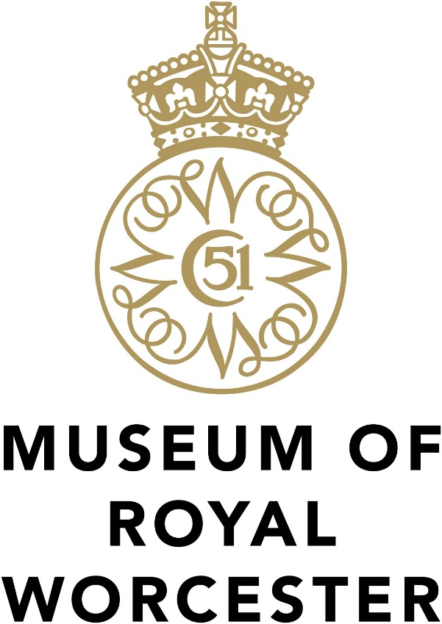
For immediate release
Museum of Royal Worcester reveals City’s porcelain connections with the Arts of Islam
The Museum of Royal Worcester invites people to see stunning objects and archive material not usually on show in a brand-new display exploring ‘Worcester porcelain and the Arts of Islam: creativity, commerce, and exchange’, which opens at the Museum on Saturday 10th October. The following Saturday 17th October at 2pm audiences can join an ONLINE Facebook Live Q&A event with the curator Fuchsia Hart where she will be handling and talking in detail about some of the exhibits and discussing her research into the fascinating links between Worcester’s porcelain factories and the Islamic world.
Sophie Heath, Museum Director, explains “Worcester porcelain borrowed design inspiration from all over the world to keep up with the tastes of its customers. This started with China and Japan in the 18th century but the industry also looked to the arts and cultural traditions of the Islamic worlds of the Middle East and India in the 19th and 20th centuries influencing some of their most elaborate and high status objects. In 2019 we achieved project funding to enable an expert in the arts and design of Islam to spend time looking at our collections and archives that bear Arabic calligraphy and borrow patterns and shapes from these cultural traditions. We’re delighted to be now sharing what we’ve learned about Worcester porcelain’s global connections in this new display and in our first ever Facebook Live event.”
Cathedral Ward, Worcester City Councillor, Jabba Riaz says “The Museum is interested in hearing from our local communities about what these objects mean to them and invite people to visit and get involved, ask questions and take part in person and online to find out more. It’s a really beautiful project which highlights the journey of Royal Worcester into the Middle East and Asia and how Islamic art calligraphy and geometry influenced many of the designs at the time”
The project was enabled by the West Midlands Museum Development ‘Expert Eye' programme and the Islamic Art and Culture Subject Specialist Network, both supported by Arts Council England. Fuchsia Hart, a PhD candidate at the University of Oxford (and former researcher for the V&A’s upcoming Iran exhibition) spent time looking at the Museum’s ceramic collections and rich factory archive. She translated inscriptions on items commissioned for Muslim rulers, ranging from an 1820 pink breakfast service plate created by Chamberlains for Azam Jah, Nawab of the Carnatic in India, to late 20th century, richly gilded dinner services for leaders of the Gulf states. An exciting discovery was rare books in the Museum’s Design Library that show the factories were collecting early publications illustrating the art and design of Islam for European audiences – enabling factory artists to incorporate these influences into Worcester porcelain and appeal to the fashionable Victorian taste for the exotic. The project has enabled Museum staff and volunteers to gain a much better understanding of the political and social context in which these items were created, and to improve collections records – capturing this knowledge for the future.
To attend the free Facebook Live event, visit museumofroyalworcester.org/whats-on/ for details. The ‘Worcester Porcelain and the Arts of Islam: creativity, commerce and exchange’ display in the Museum’s 20th century gallery continues to March 2021. Usual Museum admission charges apply (under-16s free) and timed entry slots are in operation. Tickets can be pre-booked at museumofroyalworcester.org or call 01905 21247.
Fuchsia Hart, Project Researcher, says “Seeing how objects traditionally thought of as ‘Islamic’ were interpreted, and reinterpreted, in Worcester, from the early 19th century to the 1980s, can help us to chart the relationship between this country and places further afield. Researchers in the field are frequently involved with large national museums but the collection and archive at the Museum of Royal Worcester demonstrates that there is much to be gained from research in regional collections which also tell a big story of global exchange.”
Sir Michael Perry GBE, Chairman of Trustees, says “We’re delighted to be sharing more extraordinary objects from the Museum, now with added insight, and recognising this exceptional heritage of local, regional, and international importance.”
Located in historic Severn Street alongside the Royal Porcelain Works arts complex and Good Roots café, the Museum of Royal Worcester engages people with the largest collection of Worcester porcelain in the world – telling the stories of the people who made and enjoyed these extraordinary objects and celebrating the colourful history of 250 years of ceramic design, local skill and innovation.
The Museum of Royal Worcester is currently open Thursdays to Saturdays, 10am to 5pm and 10am to 4pm on Sundays. As per government guidance, face masks are required to be worn in museums and galleries and other sites. Visitors are expected to wear a face covering immediately before entering and to keep it on until they leave.
Readers can help support the Museum to recover from the impact of the Covid-19 pandemic on heritage. Please donate at virginmoneygiving.com/fund/MoRW-ResilienceFund .
To find out more about the Museum of Royal Worcester, visit museumofroyalworcester.org facebook.com/TheMoRW Twitter @TheMoRW
ENDS
Editor’s Notes
For further information, images and interview opportunities, please contact Fiona Blake, Development Manager via 07938 376 965 fiona@museumofroyalworcester.org or Sophie Heath, Museum Director 07940 538 154 sophie@museumofroyalworcester.org
About the Museum of Royal Worcester
We are an independent charitable trust looking after the largest collection of Worcester porcelain in the world, over 10,000 objects, and the important factory archive. It was established in 1946 by Charles Dyson Perrins to make this design heritage available to the public as a permanent exhibition. It reopened in June 2018 following a 3-year £1.7M refurbishment project supported by The National Lottery Heritage Fund that completely refreshed and reinterpreted the displays.
The Museum relies on admission charges, gift aid on entrance, shop sales, image licensing and fundraising to sustain its work:
- £25 is enough to photograph and preserve online an object of beauty, such as the precious pattern books and artists’ watercolours
- £50 could develop learning resources for families home-schooling and schools re-opening
- £100 could fund the curator’s time spent looking after the collection and making it accessible
- £250 would replace the lost income from a group visit with a talk and help towards the launch of our Creative Ceramic Café this year
Museum of Royal Worcester, Severn St, Worcester WR1 2ND
Chairman: Sir Michael Perry GBE
Patron: Henry Sandon
“Royal Worcester” and the C51 crown device are registered by and used under kind permission from Portmeirion Group UK Ltd to whom all rights are reserved.

